1.Create a shell script to print the HTTP error code of guvi.in & print, the success/failure message based on the error code response

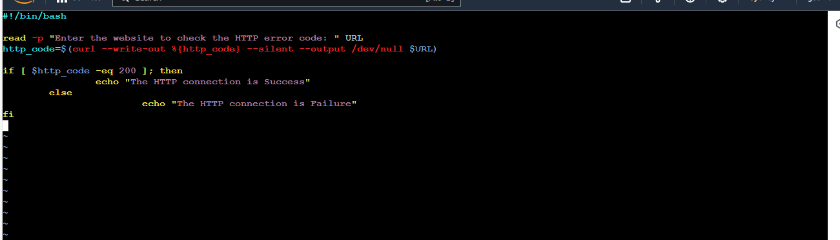



2.Given a file, replace all occurrence of the word ""give"" with ""learning"" from the 5th line till the end in only those lines that contain the word "welcome"

